**Sprint 2-Accuracy Design Document**

**November 17 2023**

**Authored by: Christopher Buzaid, Zacahry Zucconi, Royce Amburg**

**Table of Contents**

**1. Executive Summary…………………………………………………… 3**

1.1 Project Overview …………………………………………………………… 3

1.2 Purpose and Scope of this Specification ……………………………………. 3

**2. Product/ Service Description…………………………………………. 4**

2.1 Product Context……………………………………………………………... 4

2.2 User Characteristics…………………………………………………………. 4

2.3 Assumptions………………………………………………………………… 4

2.4 Constraints…………………………………………………………………... 4

2.5 Dependencies………………………………………………………………... 5

**3. REQUIREMENTS……………………………………………………. 5**

3.1 Functional Requirements……………………………………………………. 5

3.2 Security……………………………………………………………………… 6

3.2.1 Protection………………………………………………………………….. 6

3.2.2 Authorization and Authentication…………………………………………. 6

3.3 Portability……………………………………………………………………. 7

**4. Requirements Confirmation/Stakeholder Sign-Off……………….. 7**

**5. SYSTEM DESIGN…………………………………………………… 7**

5.1 Algorithm……………………………………………………………………. 7

5.2 System Flow………………………………………………………………… 8

5.3 Software……………………………………………………………………... 8

5.4 Hardware…………………………………………………………………….. 9

5.5 Test Plan……………………………………………………………………..9

5.6 Task List/Gantt Chart………………………………………………………..12

5.7 Staffing Plan…………………………………………………………………12

**1. Executive Summary**

**1.1 Project Overview**

* The Sprint 2 Accuracy project is one part of a three part project that aims to develop and code a Sphero Bolt robot to successfully complete multiple sprint courses in our classroom, HH 208. The second Sprint, Accuracy, aims to complete 5 loops of a figure 8 course. The robot will begin in the middle of the two circles that make up the figure 8 shape and should complete the 5 loops while staying within the path provided. The robot will also end in the starting location and demonstrate certain behaviors such as speaking at the end of the run and flashing multi colered lights. This project is suitable for educational purposes, STEM programs, and robotic enthusiasts.

**1.2 Purpose and Scope of this Specification**

The purpose of this specification is to describe our groups completion of the second sprint, Accuracy, in our robotics project, including our requirements, code, constraints and overall success of our second Sprint . The intended audience of this program is Dr. Eckert, and the other groups to compare how our robots made it across the course.

**In scope:**

* The group will build a fully functional robot program to perform a “figure 8 course” by the due date of Sprint 2: Accuracy.
* All group members will work on this document and the code for Sprint 2- Accuracy. The date of completion will be before 11/20/23, at 11:59 PM

**Out of scope:**

* Sprint 3 can not be completed at the time being, and therefore is out of scope:
* Sprint 3: Agility (November 30th, 2023 at 11:59 PM)
* The group will build a fully functional robot program to avoid 3 obstacles on an obstacle course through the classroom by the due date of Sprint 3: Agility.
* Presentation on robot code and triathlon (December 5th, 2023 1:00 PM)
* The group will build a fully functional robot that is able to travel around the periphery of room HH 208 and speak. ***Completed***
* All group members will work on the document and code for Sprint 1- Endurance. The date of completion will be before 11/7/23, at 11:59 PM ***Completed***

**2. Product/ Service Description**

The product is a sphere that is able to roll and spin in any direction that is controlled via user input from block code in the Sphero Edu application. Its environment that the robot is in, is a classroom with blue tape on the ground to mark its path with obstacles like desks and chairs making the margin for error slim. The robot can “talk” through the speakers of a computer and it moves using a motor that shifts its weight towards a specific direction. The robot even emits colored lights that can be changed using the block code.

**2.1 Product Context**

This product relates to the famous automobiles we all drive. They both require user input in order to move. The robot is unable to move on its own, and requires the user to input, block code, in order for it to move. This is much like how a car can not drive itself, and require the user (aka. the driver) to start the engine using a key, use the gas pedals, and steering wheel, in order to make it move.

**2.2 User Characteristics**

* Users of this project may include students, educators, and robotics enthusiasts with varying levels of experience and technical expertise. Participants are expected to possess basic programming knowledge and be able to control the robot using compatible devices.
  + Student- Possess a basic understanding of programming concepts and robotics. Are actively interested in studying computer science or robotics and are eager to learn more of the subject.
  + Educator- A teacher or professor in the field of computer science or robotics who fully understands robotics and has years of experience in the field and will use the product as a tool for teaching their students.
  + Robotics Enthusiasts- Passionate about robotics and have a varying range of experience levels that may come from DIY robotic projects.

**2.3 Assumptions**

The equipment is not always available due to only one of us having access to the robot. We also all have different schedules making it challenging to find times to work together on the project. User expertise is a factor as well due to some of us having more background experience with coding than others. The Sphero operating system is constantly available as it is a program on our devices,however the Sphero robot itself is not constantly available.

**2.4 Constraints**

* Room Availability - HH room 208 isn't always available as classes and lectures occur there multiple times every day. The group must find windows throughout the day to go to the room.
* Classmates Availability - The group must find windows throughout the day to meet to work on the project that best works with everyone's schedule.
* System constraints could include a device such as a laptop not having access to download the Sphero Edu application.
* The use of block code may be a constraint as some members may not have experience in the use of block coding.

**2.5 Dependencies**

* Having the programed functional robot is a dependency
* The course needs to be set up before we can execute the requirements. (Yellow Square, Blue tape, Obstacles etc)
* In order to connect to the robot you must download the Sphero Edu application onto your device.

**3. Requirements**

***3.1 Functional Requirements***

| **Req#** | **Requirement** | **Comments** | **Priority** | **Date Reviewed** | **SME Reviewed / Approved** |
| --- | --- | --- | --- | --- | --- |
| **ACCUR_01** | System must successfully travel in a figure 8 shape while staying within the path provided | This is a “Must have” as the Sphero robot must run the figure eight course without going out of the provided path | 1 | 11/14/2023 | 11/20/2023  Approved |
| **ACCUR_02** | The system must run the course successfully 5 times | Another “Must have” for this project as the robot must loop the figure 8 shape five times while staying within the provided path | 1 | 11/14/2023 | 11/20/2023  Approved |
| **ACCUR_03** | System must start in the square in the middle of the figure 8 shape | The blue tape in between the two circles indicates where the robot is supposed to be placed. Put it here, start the program and watch it complete the figure 8 course | 1 | 11/14/2023 | 11/20/2023  Approved |
| **ACCUR_04** | System must stop at it’s starting location | This is the final piece of the course where the robot has to stop where it started, in between the two circles. | 1 | 11/14/2023 | 11/20/2023  Approved |
| **ACCUR_05** | System must flash multi-colored lights for 5 seconds and speak “I am the winner” after the end of the 5th loop | This signifies that the test is complete, and adds more character to the robot | 1 | 11/14/2023 | 11/20/2023  Approved |
| **ACCUR_06** | System must have representative sensor data after the completion of the accuracy course | Must be completed to show the figure 8 path of the robot. | 1 | 11/14/2023 | 11/20/2023  Approved |

***3.2 Security***

**3.2.1 Protection**

* Only one person has access to the robot at a time as the robot can only connect to one device/system at a time.
* The robot has a unique name that allows easy connection and helps prevent a user from connecting to another group's robot.
* A user cannot gain access to the robot if they do not have the authorized credentials, i.e. not a group member working on the project
* A user does not have the ability to view or modify the robots source code
* The robot does not have the ability to run without an authorized users connection to the robot via the Sphero Edu application

**3.2.2 Authorization and Authentication**

* The Robot will request the user to verify who they are by providing the correct credentials forcing them to authenticate themselves to the system.
* An Administrative user is able to grant users with specific permissions to the robot. Internal users will have access to make modifications to the robot. End users will have access to connect to the robot and run the system
* When a user authenticates themselves successfully we will ask for the users email or phone number and store their device information. When a preexisting user authenticates to the system, we give them the ability to sign in with a one time passcode instead of their username and password.

**3.3 Portability**

The Sphero robot has high portability potential. The robot itself is very small, able to fit in your hand and comes in a carrying case that has the ability to hold the robot and the charger. It is also very easy to obtain access to the Sphero Edu as it can be downloaded off of the Sphero website onto a smartphone, laptop, and pretty much any device, as long as the device has bluetooth capabilities. You can run it with many OS systems, such as Windows, and Apple, so the type of device you are using does not matter.

**4.**

| **Meeting Date** | **Attendees (name and role)** | **Comments** |
| --- | --- | --- |
| **11/14/2023** | **Chris Buzaid(Block code, System Design Document) Zachary Zucconi (System Design Document)** | **Confirmed all except ACCUR_02, ACCUR_01, ACCUR_04** |
| **11/16/2023** | **Chris Buzaid(Block code, System Design Document)** | **Confirmed all except ACCUR_02** |
| **11/20/2023** | **Chris Buzaid(Block code, System Design Document)** | **Confirmed all** |

**5. System Design**

**5.1 Algorithm**

Step 1: Place robot at starting location: In the middle of the two circles of the figure 8

Step 2: Aim robot so that it goes along the path of the first circle in the figure 8 shape

Step 3: Use block code to make the robot move in a circular path that stays within the first circle going in a clockwise direction

Step 4: Use block code to make the robot change direction when in the middle of figure 8 shape

Step 5: Use block code to make the robot move in a circular path that stays within the second circle going in a counter-clockwise direction

Step 6: Use block code to have the robot loop the path a total of 5 times

Step 7: Have robot stop at the starting location: In the middle of the two circles of the figure 8

Step 8: Use block code to have robot speak “I am the winner”

Step 9: Use block code so that the robot flashes multi-colored lights for 5 seconds

**5.2 System Flow**

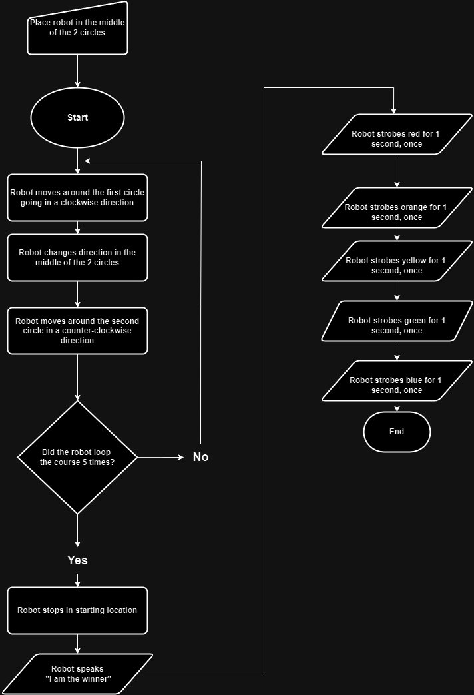

**5.3 Software**

* The software used to code the Sphero Robot was block code that was constructed in the Sphero Edu application.

**Code and sensor data is pictured below**

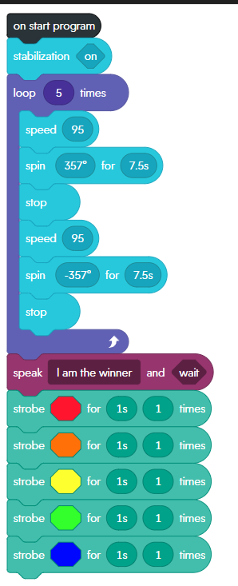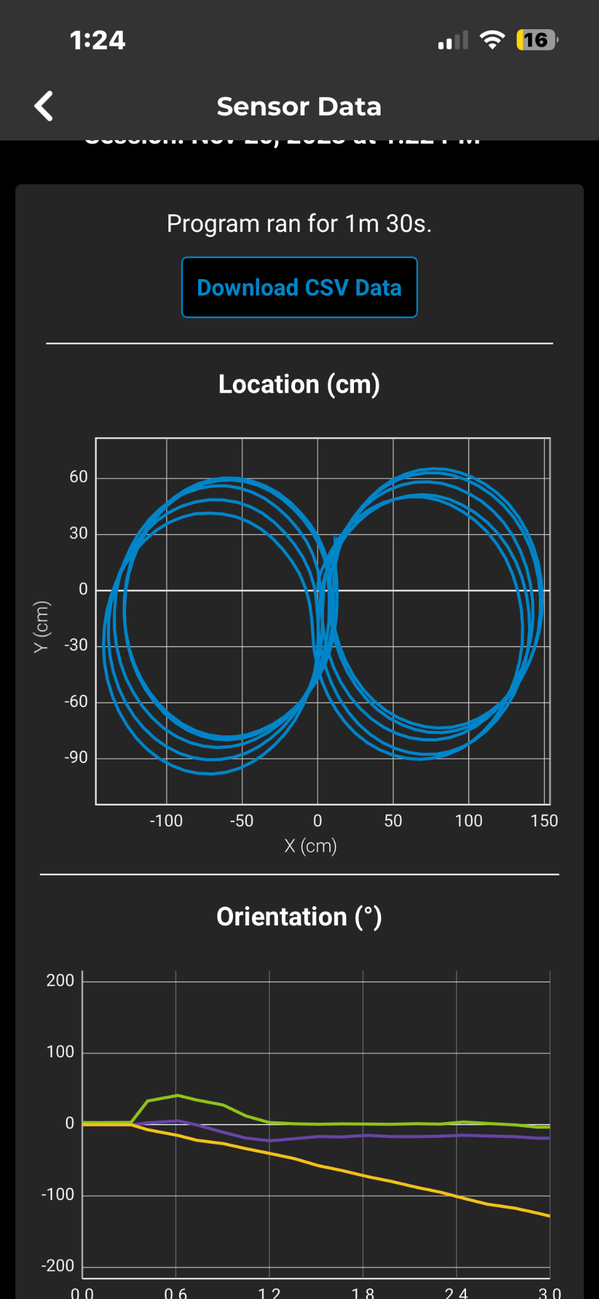

**5.4 Hardware**

* Sphero Edu application on a Windows Lenovo laptop, to develop, build, and test the code.
* An Apple Iphone was used to record the video and also to analyze the sensor data provided by the Sphero robot.

## **5.5 Test Plan**

| Reason for Test Case | Test Date | Expected Output | Observed Output | Staff Name | Pass/Fail |
| --- | --- | --- | --- | --- | --- |
| To make the robot move around the first circle while staying within the path, starting in the middle of the two circles | 11/14/23 | The robot would move around the first circle while staying within the provided path | The robot moved around the first circle but was a couple inches outside the provided path | Chris Buzaid | Fail |
| To make the robot move around the first circle while staying within the path, starting in the middle of the two circles | 11/14/23 | The robot would move around the first circle while staying within the provided path | The robot was once again a few inches outside the provided path but it was closer than the previous | Chris Buzaid | Fail |
| To make the robot move around the first circle while staying within the path, starting in the middle of the two circles | 11/14/23 | The robot would move around the first circle while staying within the provided path | The robot was once again a few inches outside the circular path that was provided | Chris Buzaid | Fail |
| To make the robot move around the first circle while staying within the path, starting in the middle of the two circles | 11/14/23 | The robot would move around the first circle while staying within the provided path | The Sphero robot successfully moved around the first circle while staying within the provided path | Chris  Buzaid | Pass |
| To make the robot change direction and start the second circle | 11/14/23 | The robot would successfully change direction and start the second circle of the figure 8 | The robot changed direction but it changed direction to late causing it to be off the path of the second circle | Chris Buzaid | Fail |
| To make the robot change direction and start the second circle | 11/14/23 | The robot would successfully change direction and start the second circle of the figure 8 | The Sphero robot successfully changed direction and started the path for the second circle in the figure 8 | Chris Buzaid | Pass |
| To make the robot move around the second circle while staying within the path | 11/16/23 | The robot would move around the second circle while staying within the provided path | The robot was a couple inches outside of the provided circular path | Chris Buzaid | Fail |
| To make the robot move around the second circle while staying within the path | 11/16/23 | The robot would move around the second circle while staying within the provided path | The robots circular path was much smaller than than the circular path plotted out on the floor | Chris Buzaid | Fail |
| To make the robot move around the second circle while staying within the path | 11/16/23 | The robot would move around the second circle while staying within the provided path | The Sphero robot successfully moved around the second circle while staying within the provided path | Chris Buzaid | Pass |
| To make the robot loop the figure 8 course a total of 5 times and stop in the starting location | 11/19/23 | The robot would successfully loop the figure 8 course 5 times and stop in the starting location | The robot looped the course 5 times, however on some of the loops the robot was off the path and did not stop in the starting location | Chris Buzaid | Fail |
| To make the robot loop the figure 8 course a total of 5 times and stop in the starting location | 11/19/23 | The robot would successfully loop the figure 8 course 5 times and stop in the starting location | The robot once again looped the course 5 times however on one of the loops it hit the floor outlet causing it to go off course and not stop in starting location | Chris Buzaid | Fail |
| To make the robot loop the figure 8 course a total of 5 times and stop in the starting location | 11/20/23 | The robot would successfully loop the figure 8 course 5 times and stop in the starting location | The robot successfully looped the course 5 times staying on the correct path and stopped in the starting location | Chris Buzaid | Pass |

**5.6 Task list/Gantt Chart**

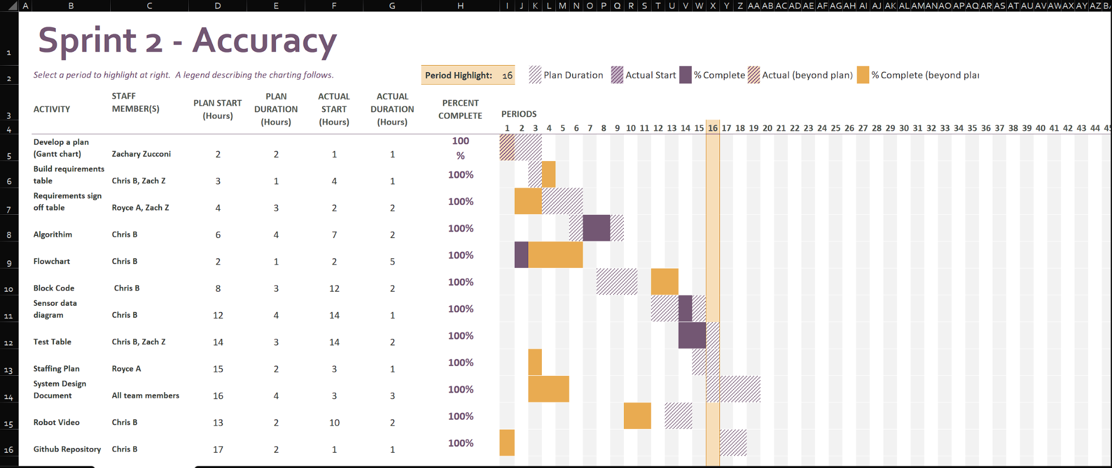

**5.7 Staffing Plan**

| Name | Role | Responsibility | Reports To |
| --- | --- | --- | --- |
| Zachary Zucconi | Assistant | Fill out sections embedded in System Design Document: Test Table, Requirements table etc. | Chris Buzaid |
| Chris Buzaid | Manager | Write the Block Code for robot and sensor data diagram.  Fill out sections embedded in the System Design Document, Test Table, Requirements table, etc. | Chris Buzaid |
| Royce Amburg | Assistant | Fill out sections in System Design document: Accuracy Design etc. | Chris Buzaid |